LOUISE CORBALLY – G00313361

The LAMP GENIE

Project Proposal | Individual Project

**Table of Content**

1. Proposal
   1. Website
2. Design
   1. Content Flow Chart
   2. Wireframe
3. Technical Specs
   1. Project Plan & WBS
   2. Goals for Site
4. Research and Inspiration
5. Images and Video
   1. Text and Font

**1.0 Proposal**

For my Individual project, I will be creating a website for a local craftsman. My aim for the website is to showcase his work and be able to reserve products for collection or order online. The main products that will be stocked on the site are handmade bottle lamps, the lamps can be made from any glass bottle of the customers choosing.

* 1. **Website**

The Website will consist of 4pages, the home page, the product page, a gallery and an about page. Each page will go into further detailing.

Home page will consist of an overview of the products, with a bootstrap carousel showcasing some of the products.

The about page will provide information about the company, ti will have a frequently asked question section and once the business grows it will have a show some reviews from customers.

The Products page will have information on all products for sale and their pricing.

Lastly will be the gallery page which will showcase photos of the products from different angles and in different lighting.

**2.0 Design**

For the design of the website I will be have a navigation bar at the top of the screen that will move along with the page when it scrolls up and down. There will be a footer at the bottom that contains links to social media sites.

I decided to go with the colors blue and white for the site, I took this inspiration from some of the lamps that were created, as a lot of them have blue stones inside them. I also feels this gives a simple and fresh feel to the site and is a great use of white space.

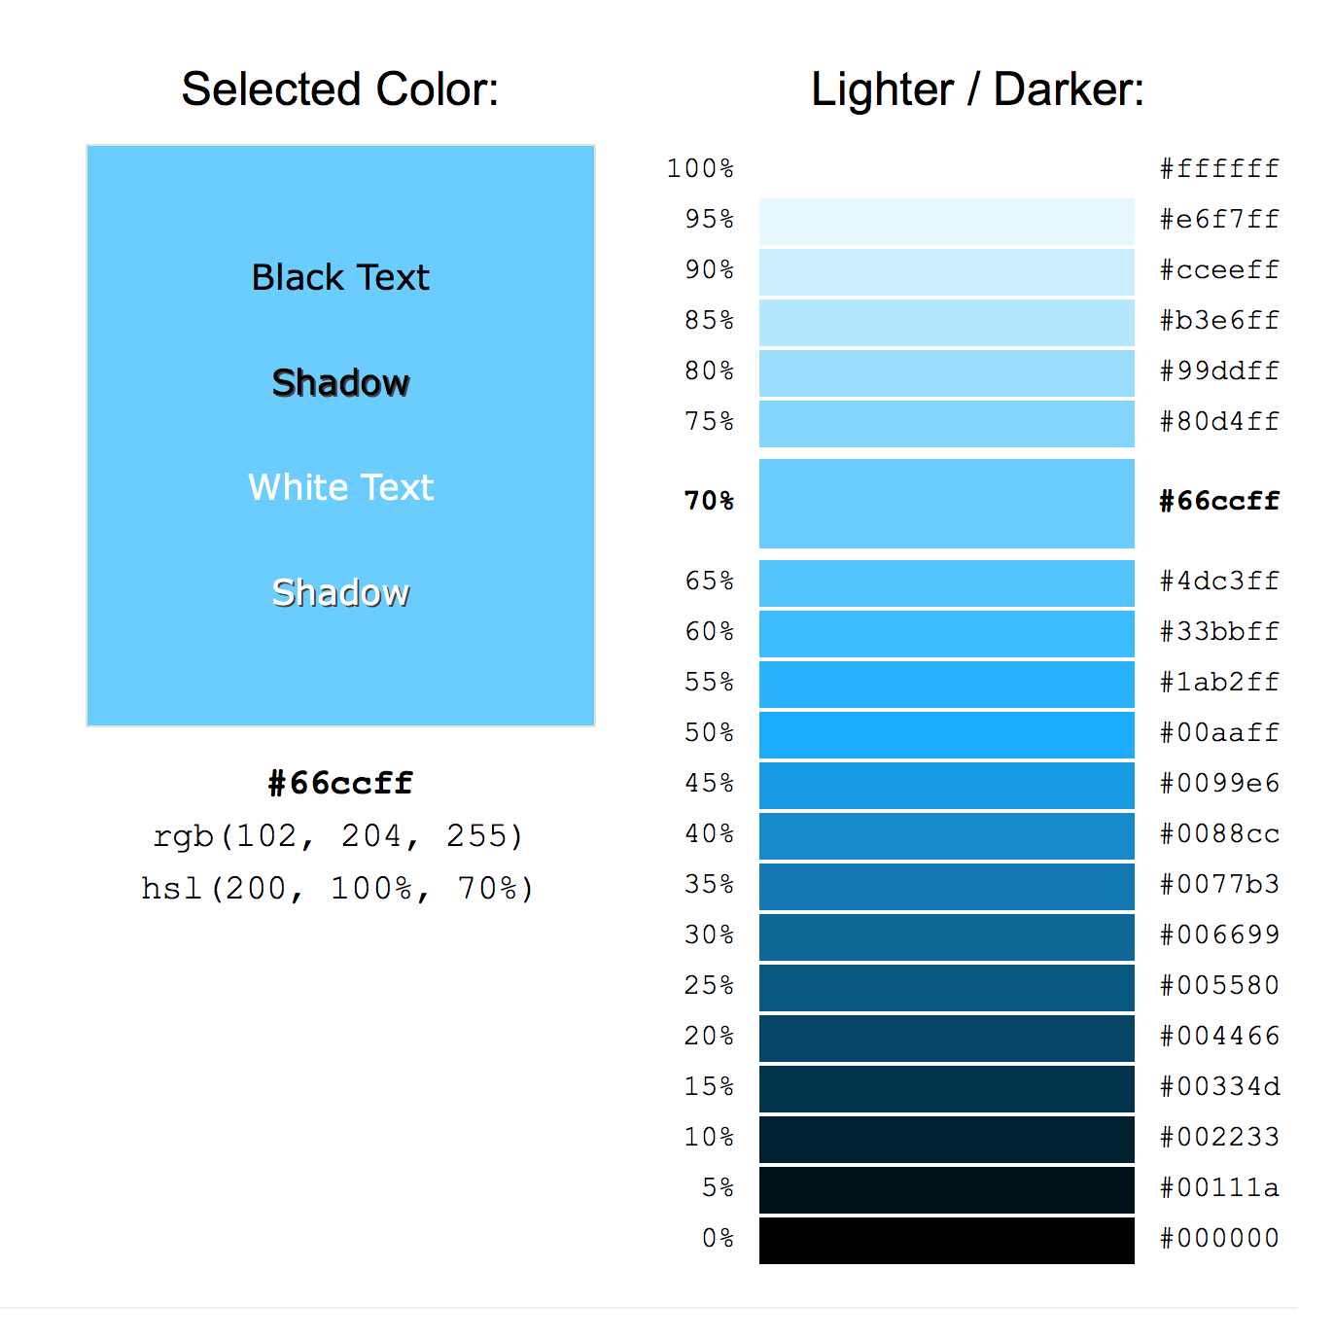

**2.1 Content flow chart**

I have created a content flowchart to give the company an idea of what the website will consist of. I created this flowchart in draw.io

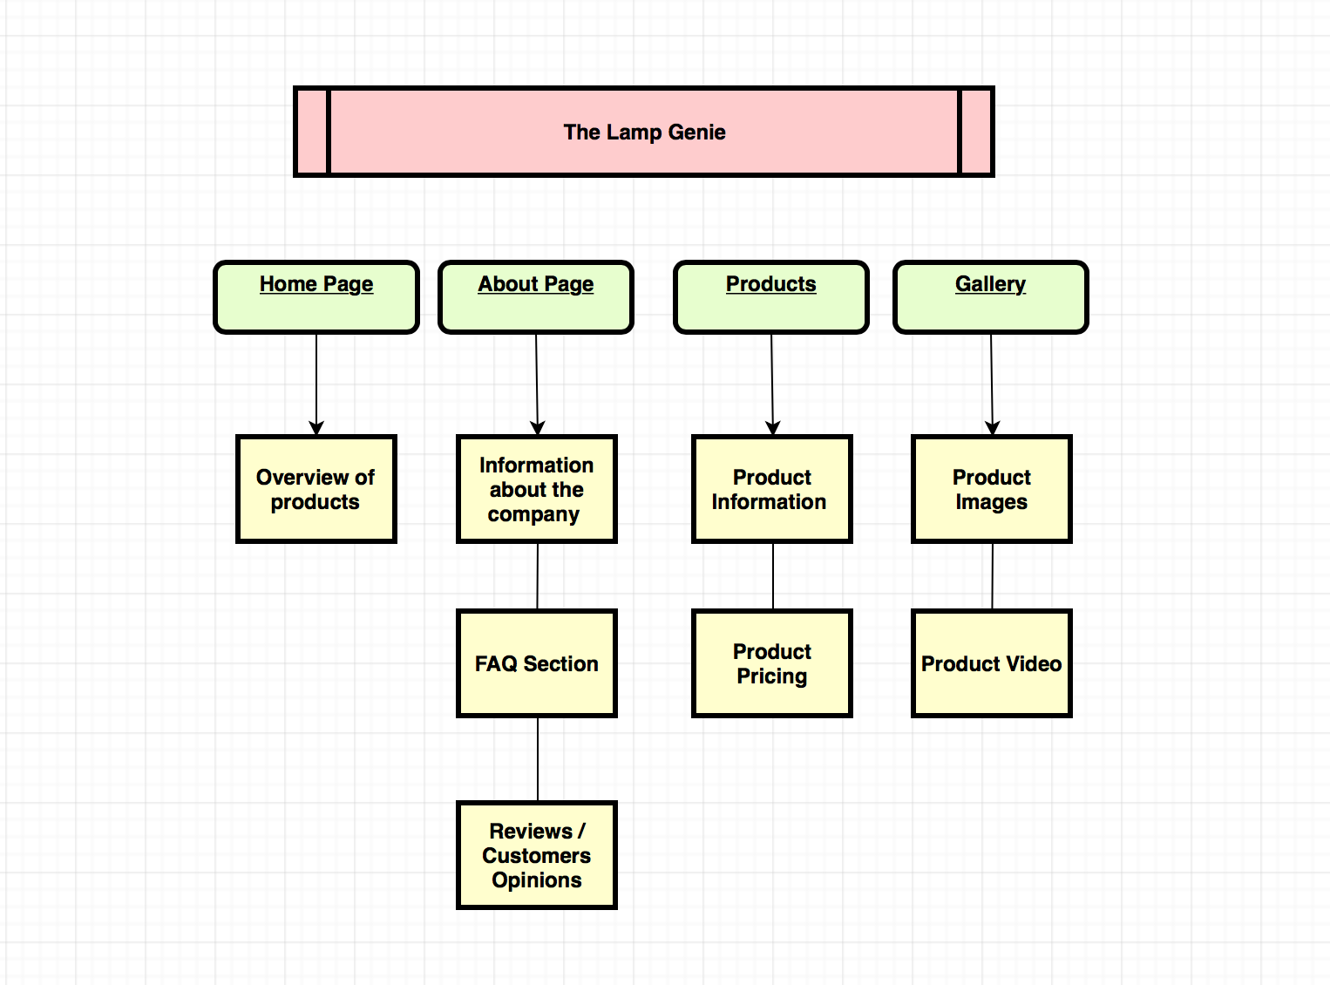

**2.2 Wireframe**

I created a wireframe to give my client an idea of what the website layout will look like. I created it using mockflow.com

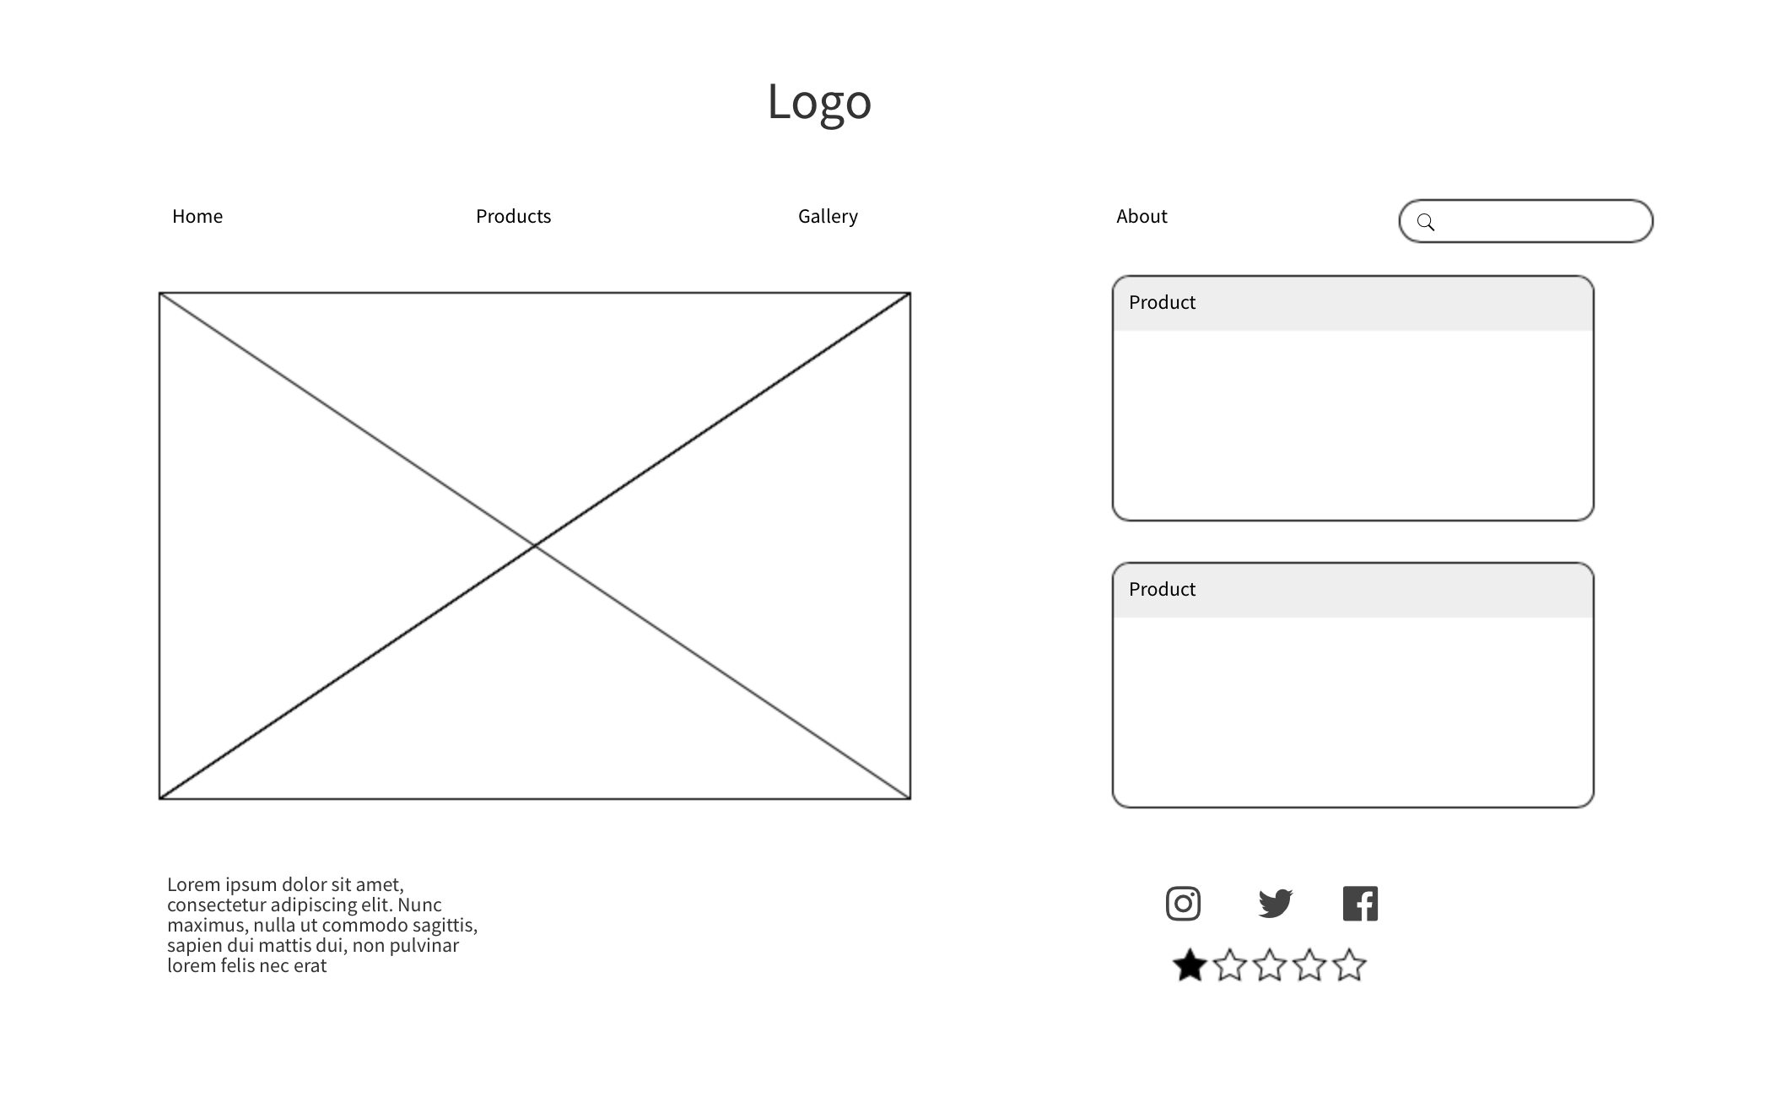

**3.0 Technical Spec and Languages**

I will be using a mix of different programming languages and applications ranging from coding to photo editing.

To build my website I will be using

* HTML
* CSS
* JavaScript
* Bootstrap
* PHP
* Java
* DigiWeb hosting

For the application to write the code and edit the photos/video I will be using:

* Visual Studio Code
* Eclipse
* Adobe Photoshop
* Adobe Illustrator
* Adobe Premiere Pro
* Adobe InDesign

For my equipment, I will be using:

* Nikon D3200 DSLR camera
* Softbox lighting
* Tripod
* Macbook Pro

**3.1 Project Plan/List of Tasks**

* Meet with client – discuss ideas & specs
* Brainstorm – mind map
* Design content flow chart
* Take photos of products
* Create Logo
* Begin coding – basic elements
* Prototype demo – 20th February
* Start more in-depth programming
* Edit photos in Photoshop
* Add in image & video
* Link the site to social media
* Finish coding
* Meet with client again – show them the website
* Implement any changes the client would like
* Add finishing touches
* Test website and ensure all feature are working
* Submit website

**3.2 Goals for the site**

* To create a responsive website
* To have user friendly environment
* Ensure easy navigation throughout the site
* To create all the design and features the client wants
* To ensure the website targets the appropriate audience

.

**4.0 Research & Inspiration**

Before designing the website, I researched some similar sites, there are very few who are have the same idea as my client that have a fully working website, I’ve found products similar on sites such as eBay and Etsy. There was one site who had similar product. I looked through some other websites that sold different products to get a feel for what type of layout they had. I’ve attached some images of similar websites.

The websites I have referenced are bottle-lamp.com

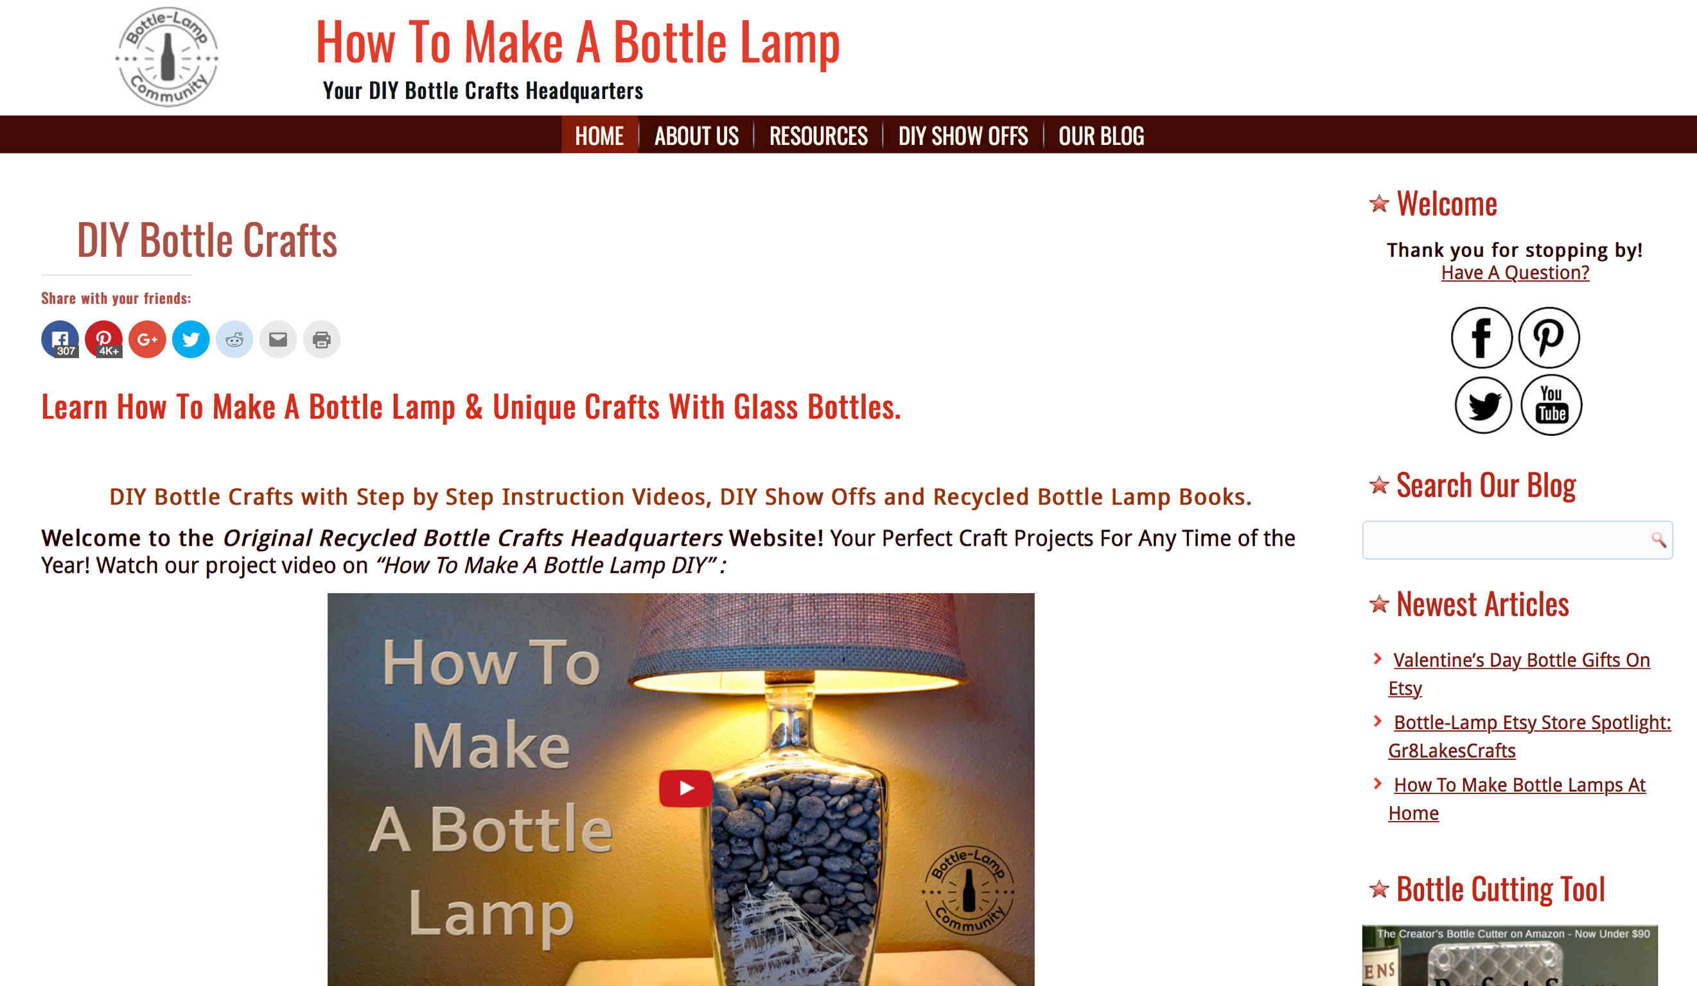

**5.0 Images & Video**

The images I will use in the website will all be taken by me and edited in Photoshop. I will use have images in the bootstrap carousel and in the gallery, I will size all the images the same to create structure throughout. For editing I will adjust the brightness and edit the background so that the product is the main focus. I will re-size all photos so an appropriate rendering size to keep the website fast and efficient.

The video of the product being made will also be shot by me. I will then edit it in Final Cut Pro so shorten it to an appropriate length, I will add some non-copy right music and I may speed up the timing of certain clips.

**5.1 Text and Font**

I will be using Verdana font for my site. It is a simple, timeless font, something that people are used to reading. This is very important as it keeps in with the fresh, simple feel of the website. I will be using font size 12-14 and mostly lowercase text however I will use uppercase for the product names.